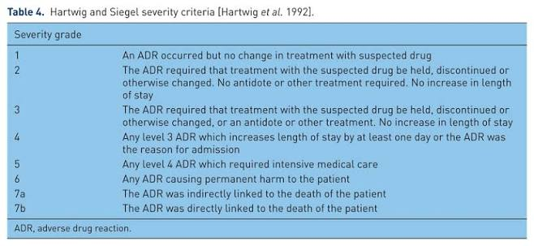

Hartwig's Severity Assessment
Criterion | Finding in this case
ADR required discontinuation/change of suspected drug? | Yes — enalapril was permanently discontinued
Was additional treatment required? | Yes — IV corticosteroid and antihistamine were administered
Was there an increase in hospital stay by ≥1 day? | Not reported
Was the ADR the reason for admission? | No — the patient presented to the emergency department and was monitored, but the case does not state that she was admitted as an inpatient
Was intensive medical care required? | No — airway equipment was kept ready, but ICU/intensive care was not required
Was permanent harm caused? | No
Did the patient die? | No
According to Hartwig and Siegel, Level 3 applies when the suspected drug is discontinued/changed and/or additional treatment is required, without an increase in length of stay. Level 4 applies if the ADR increases hospital stay by at least one day or is the reason for admission.

Final Assessment
Hartwig Severity Level: 3 — Moderate ADR
Justification: The patient developed clinically significant angioedema requiring immediate discontinuation of enalapril, emergency monitoring, and treatment with IV corticosteroid and antihistamine. However, there is no information indicating an increased hospital stay of ≥1 day, intensive medical care, permanent harm, or death. The patient recovered within 24 hours and was discharged.

